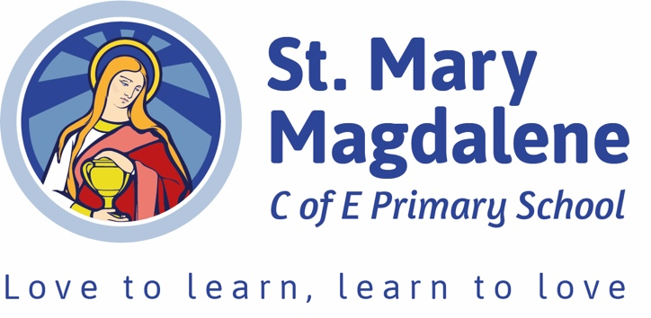
St Mary Magdalene CE Primary
Safer Eating Policy

Agreed by Governors | Pending governor approval
To be reviewed | July 2027

Our School Vision

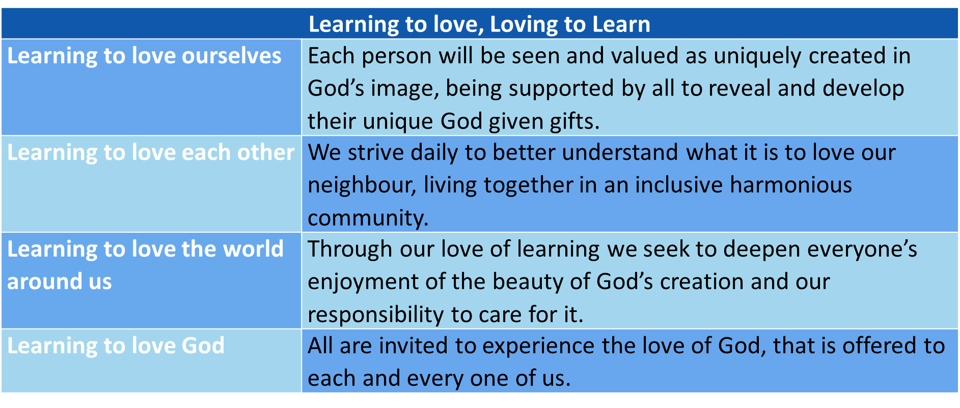

At St Mary Magdalene, each person will be seen and valued as uniquely created in God’s image, being supported by all to reveal and develop their unique God given gifts. We strive daily to better understand what it is to love our neighbour, living together in an inclusive harmonious community. Through our love of learning we seek to deepen everyone’s enjoyment of the beauty of God’s creation and our responsibility to care for it. All are invited to experience the love of God, that is offered to each and every one of us.
The teaching of Jesus in the parable of the Good Samaritan Luke 10:25 underpins our whole school vision.

This policy is aligned with the Statutory Framework for the Early Years Foundation Stage (September 2025) and the Early Years Foundation Stage Nutrition Guidance (May 2025).

Intent
At St Mary Magdalene Primary School, the safety and wellbeing of our children are at the heart of
everything we do. In line with the EYFS 2025 statutory framework and the Early Years nutrition
guidance, this policy sets out how staff in the EYFS class ensure that children eat safely, with reduced
risks of choking, allergic reactions, and other food-related hazards.

This policy applies to:
- All staff and volunteers working with children in the EYFS classes (ages 3–5)
- Lunchtime supervisors, support staff, and catering staff when supporting children at mealtimes.
- Breakfast and Afterschool Club Staff
- Parents and carers providing packed lunches.

Implementation

Supervision

A paediatric first aid (PFA) trained member of staff will always be present in the dining hall or classroom whenever children in Nursery or Reception are eating.

Staff will ensure children remain within sight and hearing at all times during meals and snacks.

Staff will closely supervise children at their tables during lunch, ensuring they remain within sight and hearing and can intervene promptly if required.

During snack times, staff will closely supervise children by continually walking around them, encouraging safe eating habits while maintaining vigilance for any signs of choking or allergic reactions.

Dietary Needs and Allergies

On entry, parents provide full details of their child’s dietary requirements, allergies, intolerances, and health conditions. This information is held by the school office and displayed (confidentially) in classrooms and the kitchen.

Each child with an allergy is known to all staff, and staff are aware of the steps that need to be taken if an allergic reaction occurs.

A named key adult (class teacher or lunchtime supervisor) checks food provision for children with allergies before it is served. Children are not permitted to share food under any circumstances.

Food Preparation and Choking Prevention

Grapes, cherry tomatoes, and similar foods cut lengthways and into quarters.

Fruits such as plums need cutting and the stone removing.

Some hard fruit/veg such as carrots may be grated, cooked, or cut into thin strips.

No nuts, seeds, popcorn, hard sweets, or other high-risk foods.

Sausages/skinned foods cut lengthways into strips (not rounds).

Eating Environment

Nursery and Reception children eat in a calm, structured environment:

EYFS children eat their lunch in the school hall or the Hopes and Dreams room depending on the needs of the children.

Mealtimes are free from running, playing, or distractions.

Staff encourage an unhurried pace, supporting children to chew thoroughly and swallow before speaking.

Incident Response

If a child chokes:

The nearest adult will apply first aid procedures immediately.

A PFA-trained member of staff must take the lead.

An ambulance will be called if required.

If an allergic reaction occurs:

The agreed steps for that child’s allergy management are followed.

Emergency services called if required.

Parents contacted immediately (after emergency services are called, if required).

All incidents will be recorded on CPOMs, reported to parents on the same day and reviewed termly to improve practice.

Staff Training

All EYFS staff (teachers, support staff, lunchtime supervisors) and Breakfast and Afterschool Club staff receive Paediatric First Aid (PFA) training

All EYFS staff and Breakfast and Afterschool Club staff receive food hygiene training.

Annual review of updates on choking prevention and food safety.

